**Exercise 4 – Teardown Methods in JUnit**

**Objective:**

To demonstrate the usage of teardown methods using @AfterEach and @AfterAll annotations in JUnit 5, which are used for resource cleanup after tests.

**Steps Followed:**

1. Created a class Database to simulate a database connection.
2. Created a test class DatabaseTest.
3. Used @BeforeEach to connect to the database before every test.
4. Used @AfterEach to disconnect after every test.
5. Used @AfterAll to print a message after all tests have run.

**Java Code Used:**

**Database.java**

public class Database {

public void connect() {

System.out.println("Connected to database.");

}

public void disconnect() {

System.out.println("Disconnected from database.");

}

public String fetchData() {

return "Data from DB";

}

}

**DatabaseTest.java**

import org.junit.jupiter.api.*;

import static org.junit.jupiter.api.Assertions.assertEquals;

public class DatabaseTest {

private Database db;

@BeforeEach

public void setUp() {

db = new Database();

db.connect();

}

@Test

public void testFetchData() {

String data = db.fetchData();

assertEquals("Data from DB", data);

}

@AfterEach

public void tearDown() {

db.disconnect();

}

@AfterAll

public static void cleanup() {

System.out.println("All database tests completed.");

}

}

**Output Screenshot:**

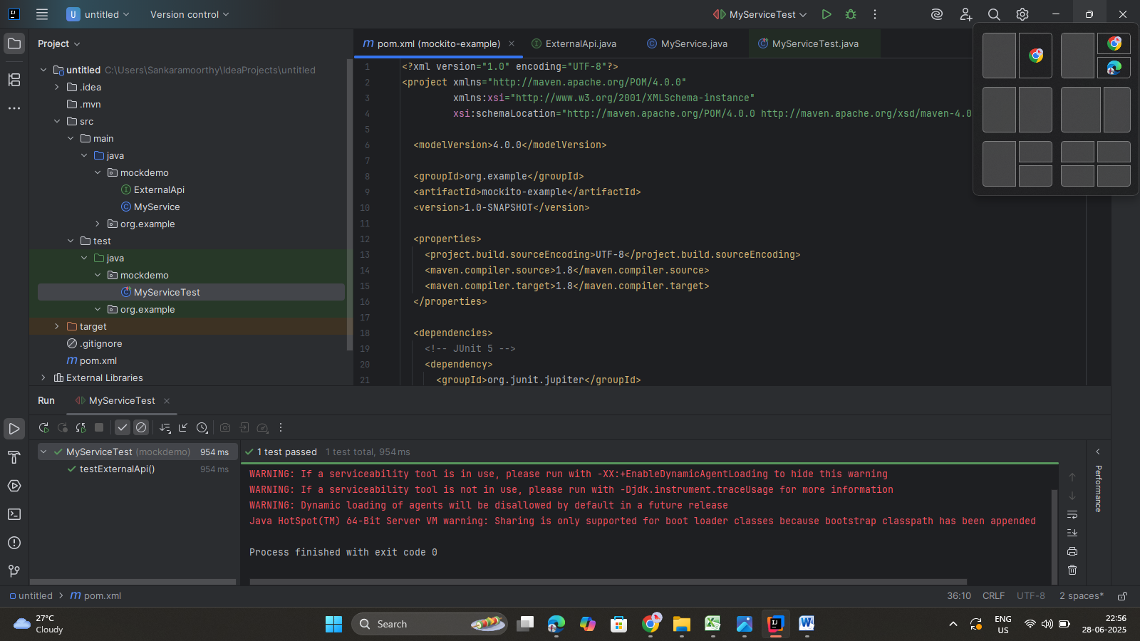

**Tools Used:**

* IntelliJ IDEA
* JUnit 5 (@BeforeEach, @AfterEach, @AfterAll, @Test)